**ECCS 1611 – Programming 1 – Fall Semester 2020**

**Major Programming Assignment # 1 (MP1) – Gotta sell them donuts…**

**Due date: Thursday 10 September 2020 at 11:59 pm**

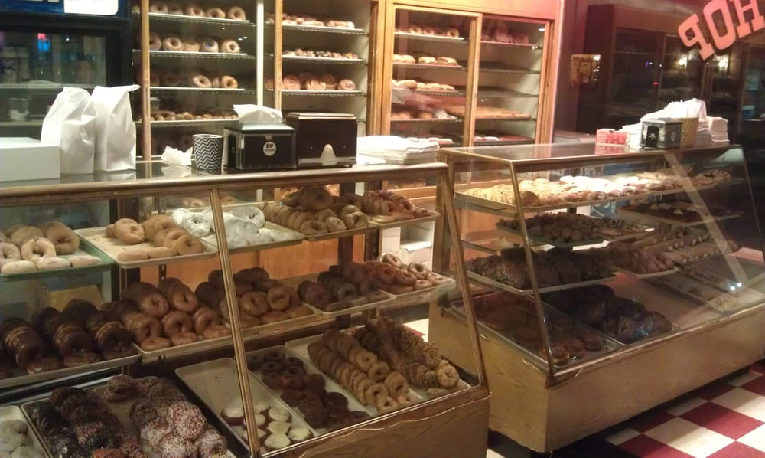

Assume that you are an employee at Jim’s Donut Shop in Vandalia. Your supervisor, upon hearing that you’re taking a programming class, has asked you to write a program that will calculate the cost of a customer’s donut purchase. Fortunately for you, there are only two categories of donuts served: regular and fancy. Regular donuts are priced at 75 cents individually, or you can get a dozen for $7.99. Fancy donuts, regardless of filling or twist, are priced at 85 cents each, or at $8.49/dozen. Additionally, the sales tax rate for food purchases within Vandalia is 7.5%. Your program is to execute once per customer, and is to ask for the number of regular and fancy donuts purchased as shown in the example runs on the next page. For purposes of calculating cost, you will need to determine the number of donuts purchased first in terms of dozens; any donuts left over are then priced individually. After displaying the cost, you must obtain the amount of payment received; you may assume that the payment is either equal to or greater than the cost. From this, you are to calculate the change to be provided to the customer and then display that information as indicated by the provided example runs.

This assignment will be evaluated by demonstrating the execution of your program via screenshots on Thursday, 10 September. This project is to be named MP1 and must be in your Google Drive folder for this course. A scoresheet for MP1 will be distributed via Moodle; this scoresheet is used to record your validation testing as to be turned in along with your source code (i.e., .cpp file).

Grading:

* Validation testing: 50 points
* Documentation and Style: 50 points - see Source Code Analysis Rubric for details

(to be handed out later)

SAMPLE RUNS (user input shown in ***red bold italics***) – your output is to look ***exactly*** the same as the following

**Run #1:**

Number of regular donuts ordered: ***1***

Number of fancy donuts ordered: ***1***

Customer owes $1.72

Customer pays $***2.00***

Change owed is $0.28 – 1 quarter, 3 pennies.

**Run #2:**

Number of regular donuts ordered: ***12***

Number of fancy donuts ordered: ***0***

Customer owes $8.59

Customer pays $***10.00***

Change owed is $1.41 – 1 dollar, 1 quarter, 1 dime, 1 nickel, 1 penny.

**Run #3:**

Number of regular donuts ordered: ***30***

Number of fancy donuts ordered: ***18***

Customer owes $36.63

Customer pays $***40.00***

Changed owed is $3.37 - 3 dollars, 1 quarter, 1 dime, 2 pennies.

**Run #4:**

Number of regular donuts ordered: ***5***

Number of fancy donuts ordered: ***7***

Customer owes $10.43

Customer pays $***10.43***

Exact payment received – no change owed.

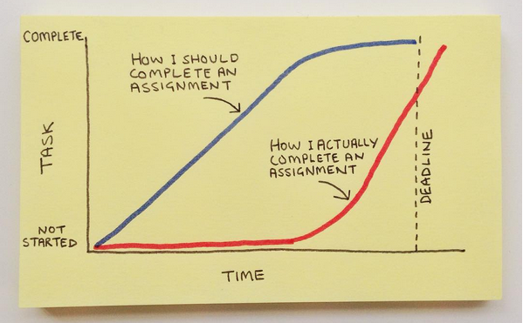

<https://instagram.com/p/7K2794G9f4/>